



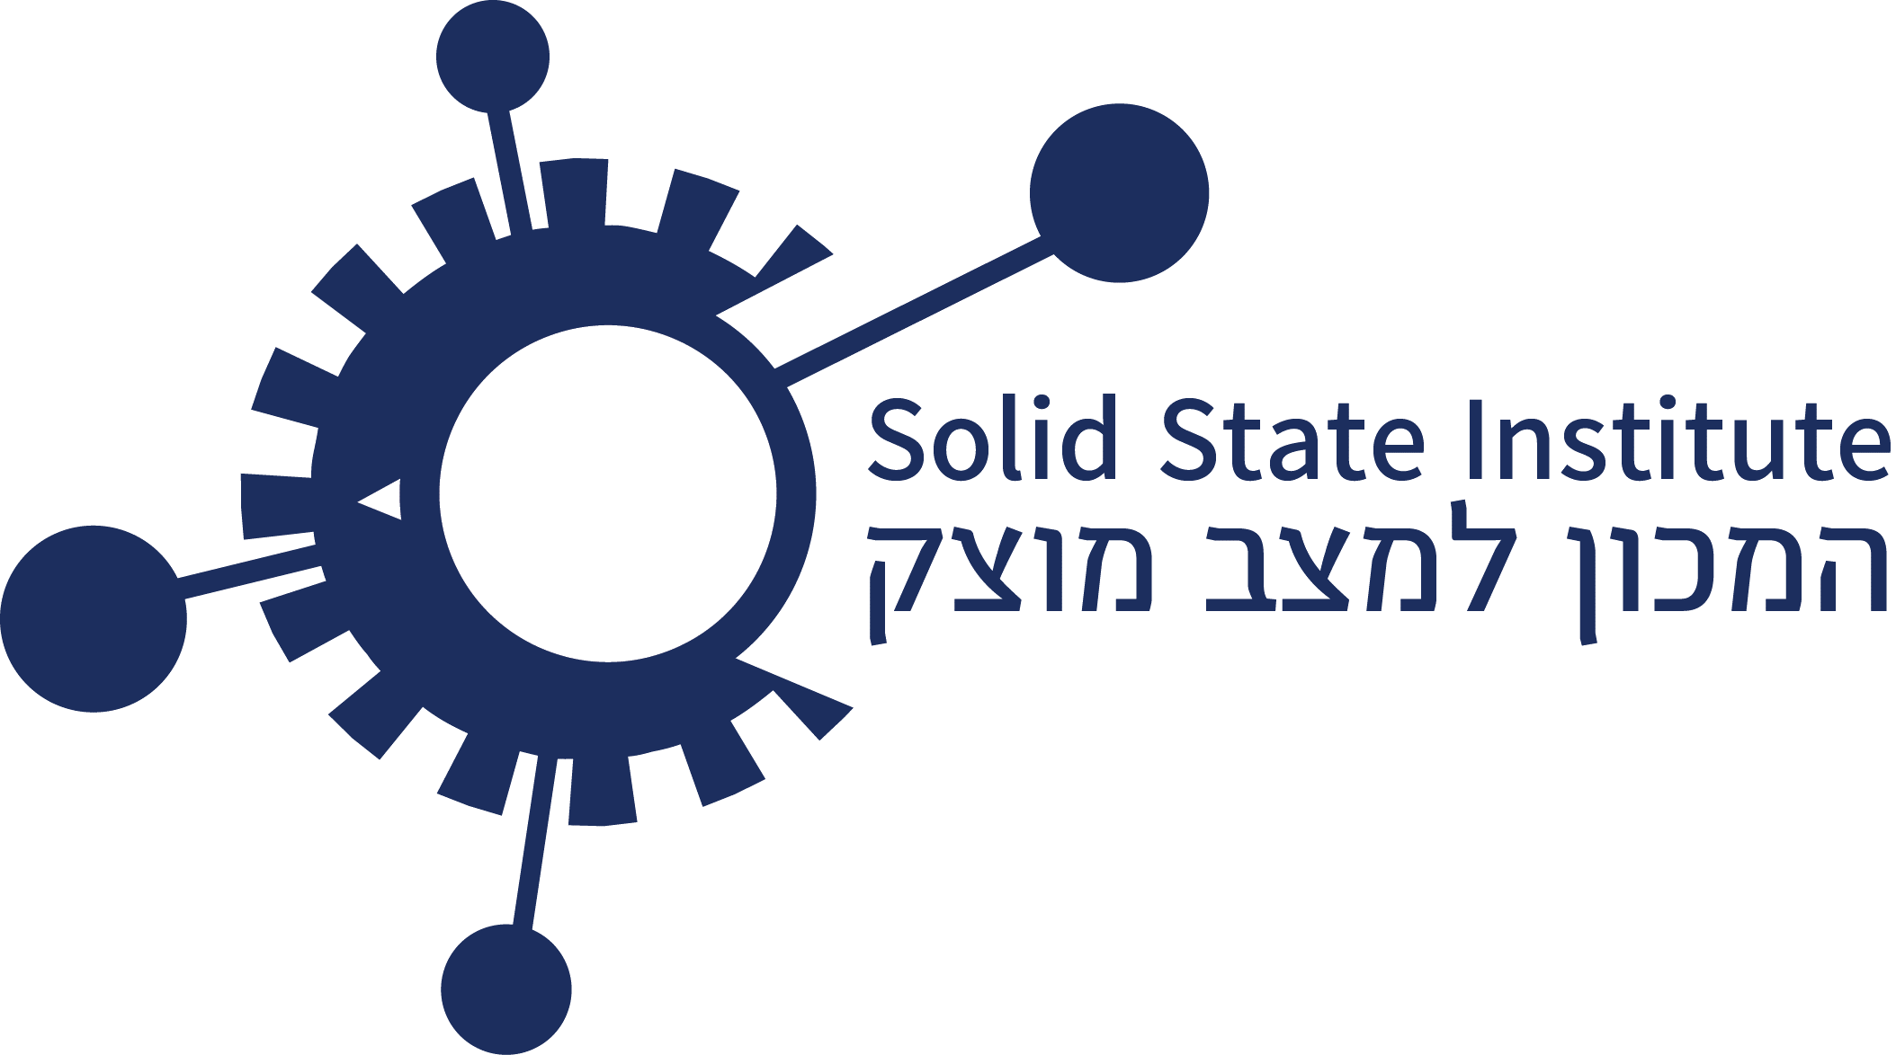

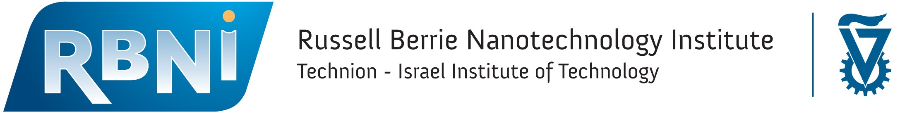

***AMO Research Day with Rafael***

***26.06.2024 between 12:00-15:15***

***Solid State Auditorium***

Potential collaborations with RBNI, The Helen Diller Quantum Center & the Solid-State Institute

**12:00-12:30 Gathering & Refreshments**

**12:30-12:40 Opening Remarks**

**12:40-13:05 Hyperpolarized noble gases: from research to applications –**

**Dr. Constantine (Costa) Feinberg**

Nuclear magnetic resonance (NMR) of noble gases is widely used in various applications and fundamental research, including medical imaging, precision sensing, and searches for new physics. In this presentation, I will introduce the key physical principles underlying NMR and explore their practical implementation across various research domains.

**13:10-13:35 DPAL - Diode Pumped Alkali Laser - Dr. Liad Levi & Dr. David Vaaknin**

DPAL has been one of the most promising laser technologies for MGW class laser.

In this lecture we will describe the principles governing DPAL systems and explain how DPAL competes with the leading technologies for MGW class lasers.

**13:40-14:05 Meta materials in High power microwave - Dr. Elhanan Maguid**

Bringing optical physics to the high-power microwave regime namely, pulse compression and beam forming. in this lecture we will describe the creation and manipulation in the time and space domains of high-power microwaves using tools inspired by, and similar to the optical regime.

**14:05-14:20 Coffee Break**

**14:20-14:45 From Magnetic Compression to Laboratory Astrophysics -**

**Dr. Kobi Cohen**

A pulsed power high-current generator can create strong magnetic fields, which in turn enable dynamic high pressure loading and hot plasma formation. I will describe some of the ongoing research in our lab, with applications ranging from optical pressure sensing and XUV spectroscopy for astrophysics.

**14:50-15:15 Cold-atom interferometry - Dr. Assaf Manor**

Cold-atom interferometry is a fascinating field in which the wave nature of matter is revealed and used. In this talk, we will cover the fundamentals and several applications of cold atom interferometers, such as ultra-sensitive gravity-meters and Gyroscopes.